SymbolicLinks or Syslinks are very helpful when developing and act kind of like a shortcut between areas on the computer.  
  
Windows is a little different than mac but uses the same thing under the name of [mklinks](https://www.educative.io/answers/mklink-windows-10). This document is an overview and walkthrough of using mklinks in case the website linked is unavailable or you have lost internet access and are looking for an offline source. It will also include [this additonal resouce showing the difference between a directory symbolic link versus a directory junction symbolic links](https://superuser.com/questions/343074/directory-junction-vs-directory-symbolic-link)

# **mklink Windows 10**

## **What is mklink?**

**mklink** is a keyword used to make symbolic-links between directories. Imagine that you wanted to store a directory somewhere and wanted a shortcut to access it from somewhere else. mklink would enable you to achieve this task.

## **Format**

mklink <Option> <Link> <Target>

**Link** is the path where you want the shortcut/symbolic-link to be, **PLUS** the name of the shortcut.

**Target** is the path to the folder you want to link to.

**Option** provides three parameters to specify the type of link you want to establish.

| Symbol | Use |
| --- | --- |
| /d or /D | Creates a **soft** symbolic link |
| /h or /H | Creates a **hard** symbolic link |
| /j or /J | Creates a **Directory Junction** |

## **Example**

### **1. Open Command Prompt**

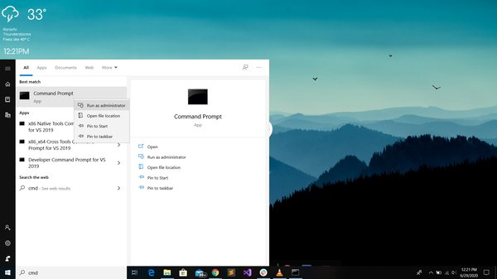

Click on the Windows symbol on the screen or press the Windows button on your keyboard to open the start-up menu. Search *cmd* or [*Command Prompt*](https://www.educative.io/edpresso/how-to-run-cmd-as-an-administrator). Right-click on it and run it as administrator.

### **2. Write mklink**

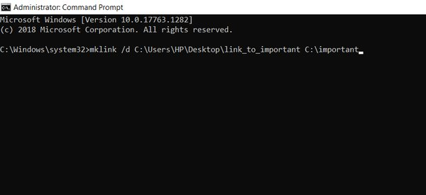

Write mklink and specify the option.

If no option is specified, then the mklink creates a *soft* link that points to the target by default.

Then, provide the path where you want to create the shortcut and add *filename* at the end of it. For example, in the above image, the path is:

C:\Users\HP\Desktop

and the filename is:

\link_to_important

Finally, add the *target* path where you want the *link* to direct you.

### **3. Completion**

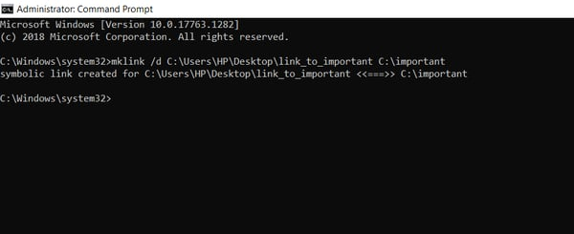

The above statement will appear if the symbolic link is created successfully.

The following describes the difference between symbolic directory links and symbolic junction directory links. Answer 1 was all I needed for clarity but I have included the others in case future developers might find those answers easier to understand.

**Question:**

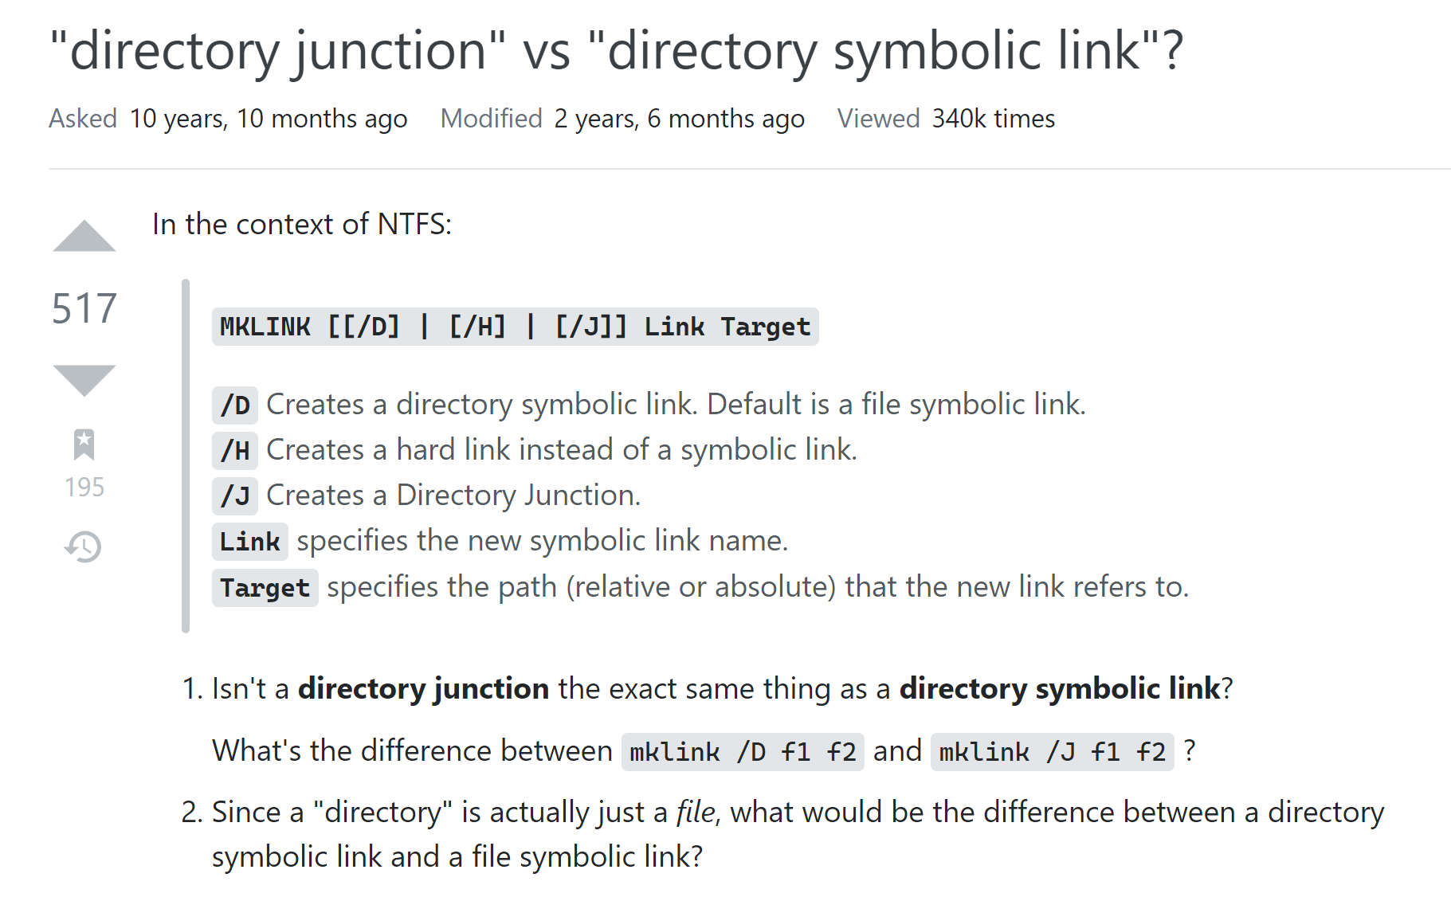

**Answer 1:**

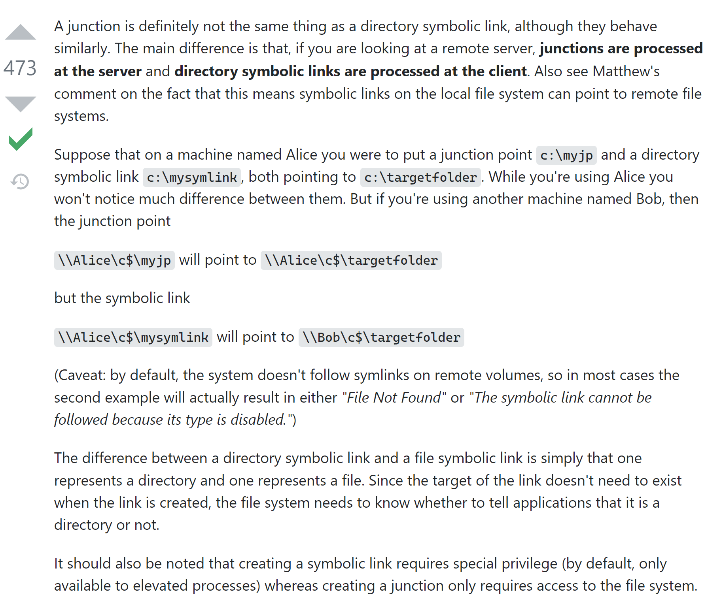

**Answer 2:**

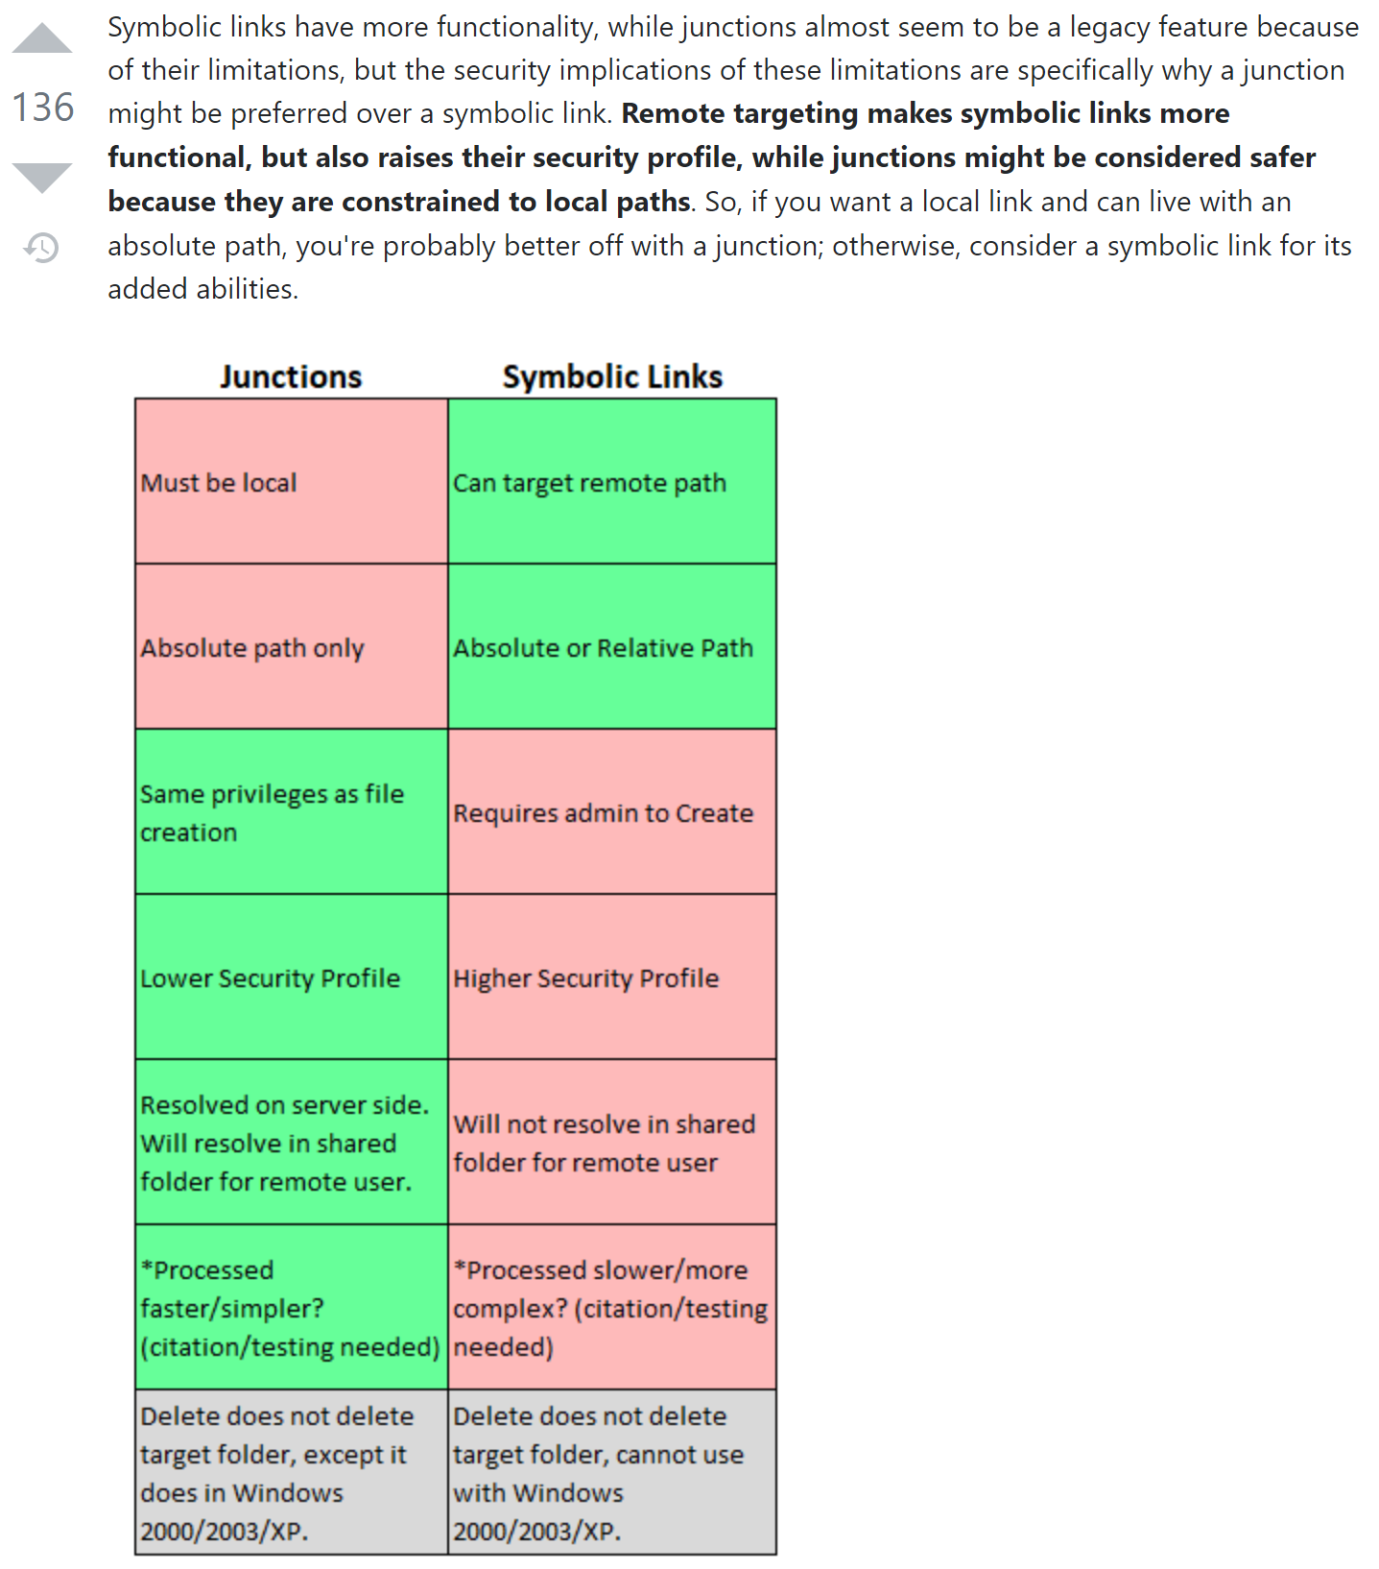

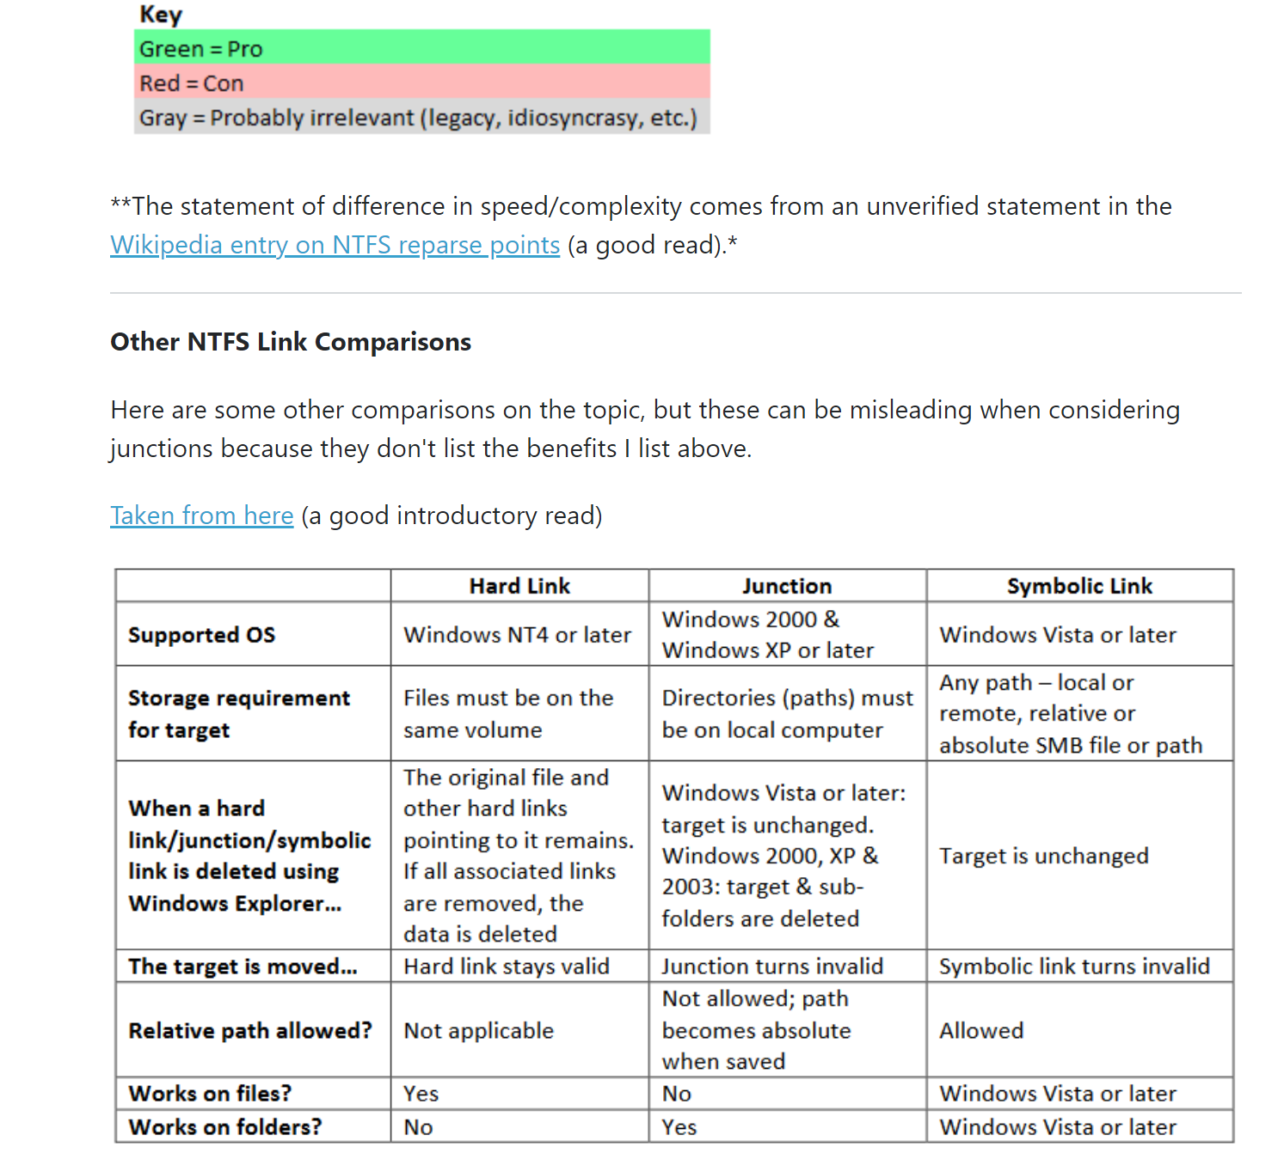

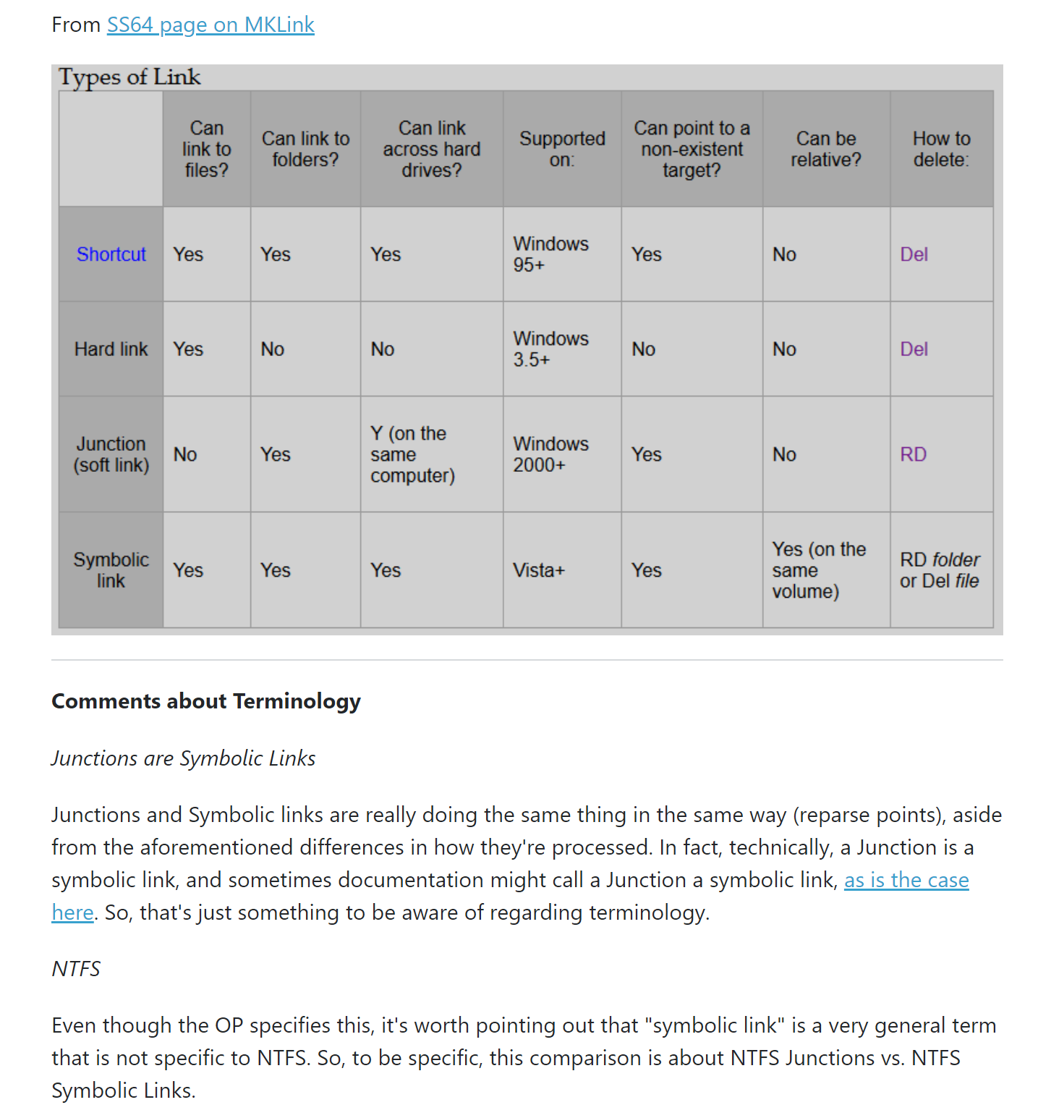

**Answer 3:**

